EXPERIMENT 3

DATE:20/04/2022

AIM: To study Terminal based Text Editor VIM and its operations

1.To check whether the VIM editor is installed or not

Enter vim

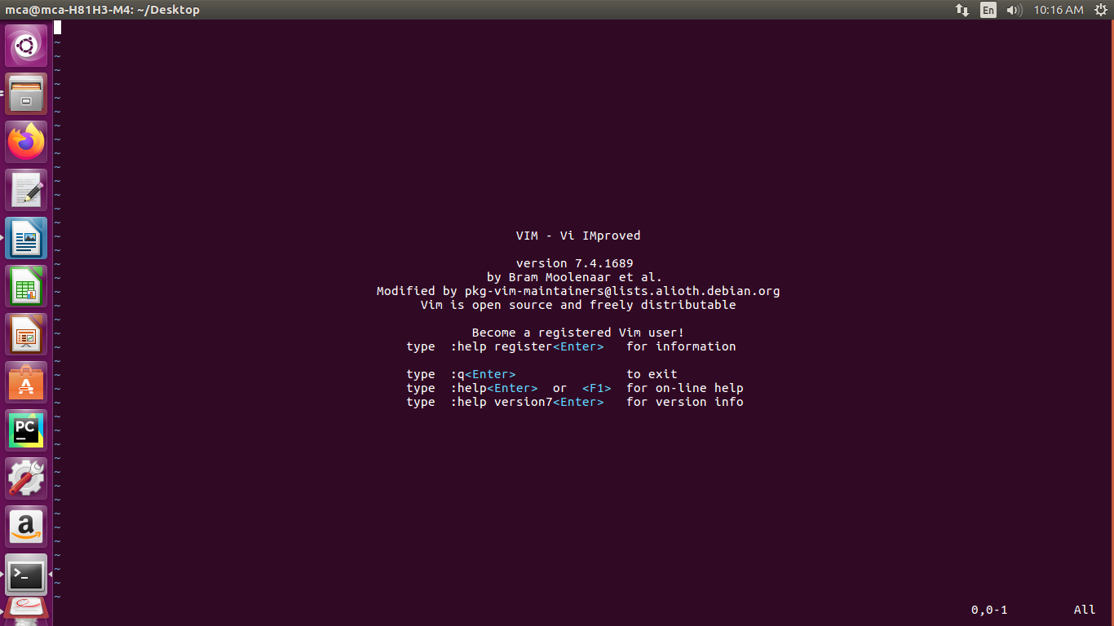

2.To open a file using VIM Editor

Enter vim Sample.java(file name)

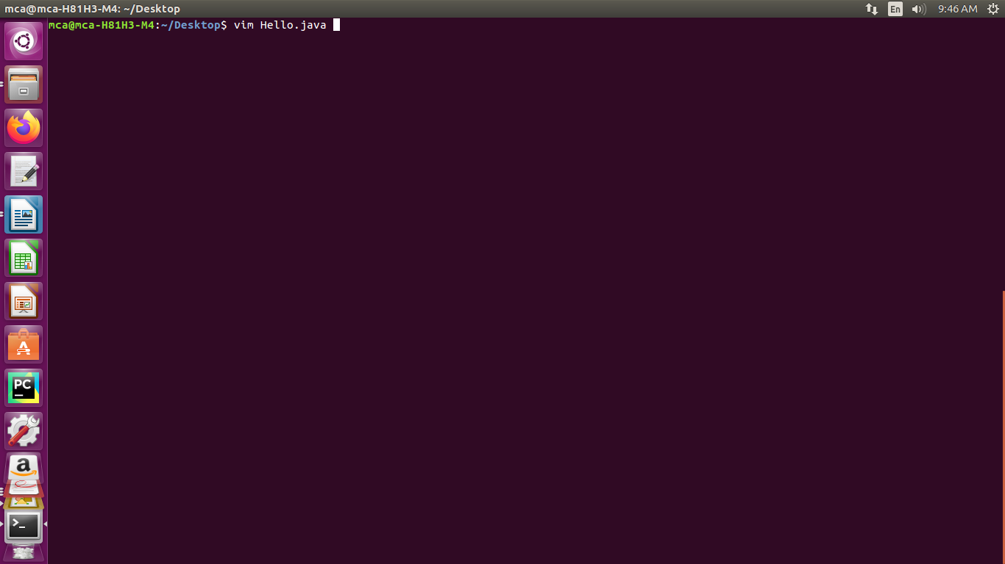
-> After opening the file

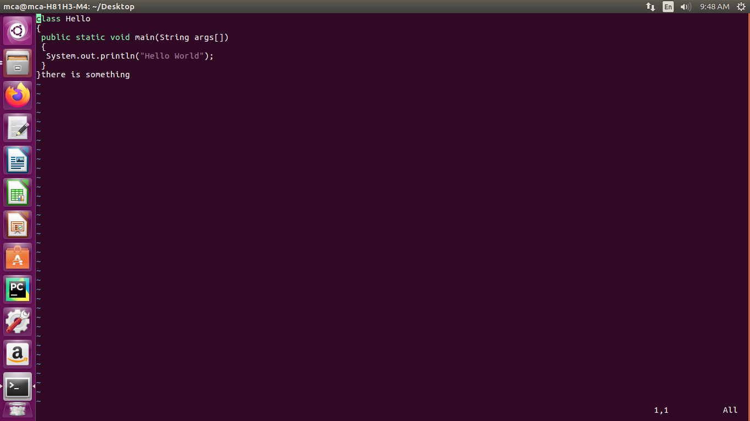

3.To edit the content in the opened file

Enter i
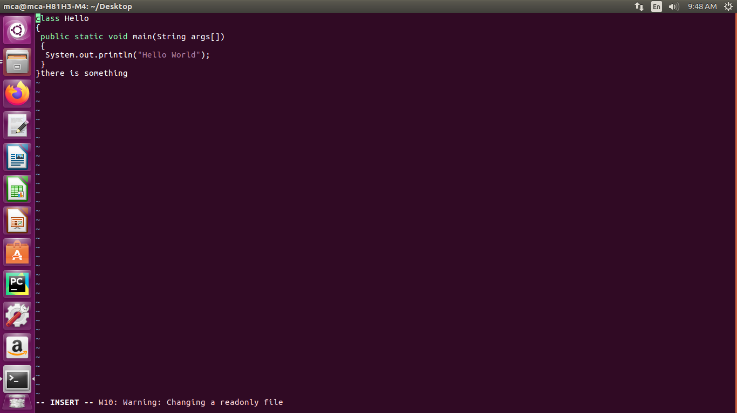
-> After editing the content

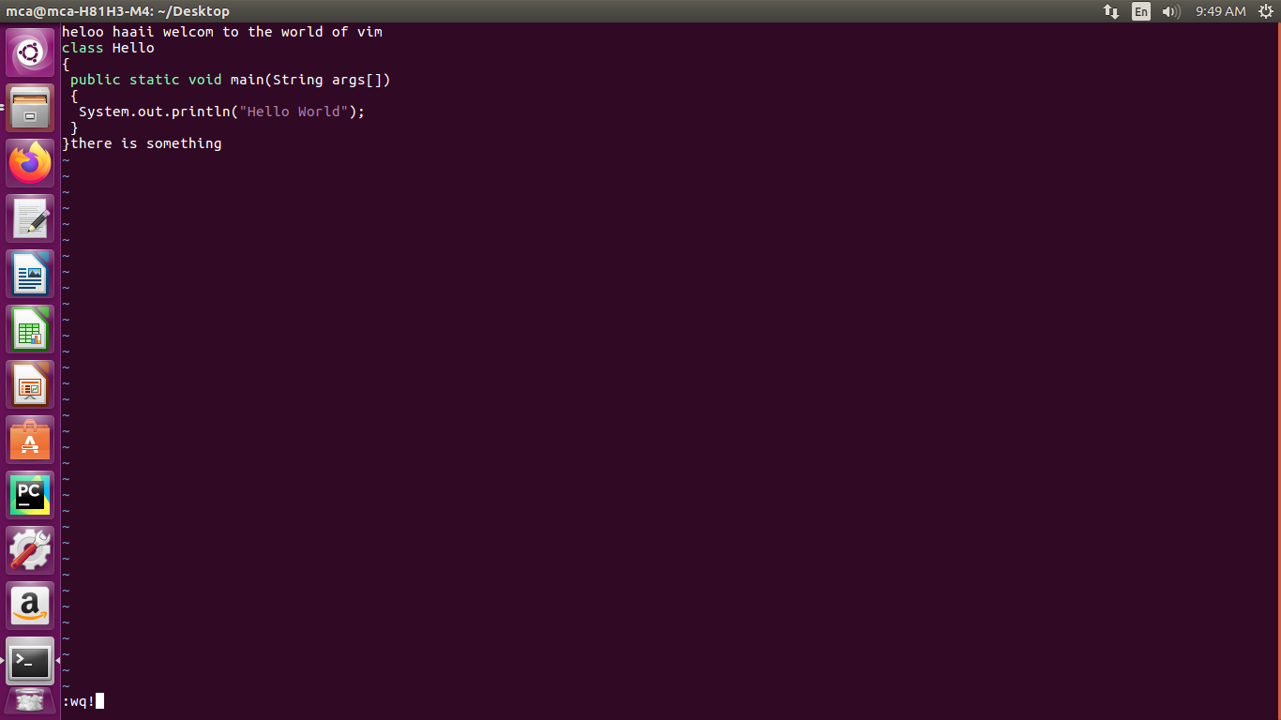

4.To exit without doing anything

Enter Esc:q

5.To exit from the VIM without saving changes

Enter Esc:q!

6.To Quit and save changes

Enter Esc:wq!

7. To UNDO

Enter Esc u
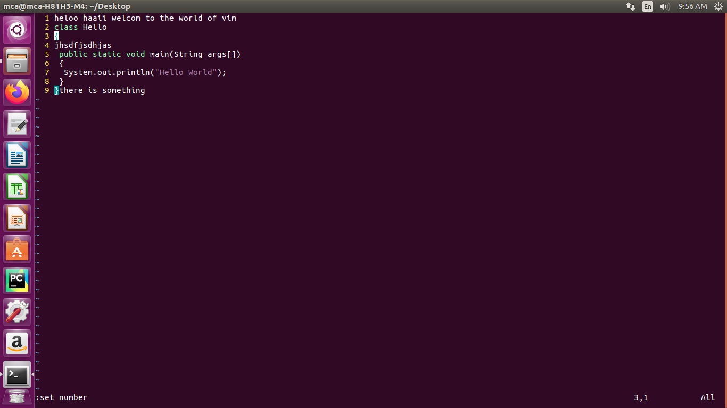

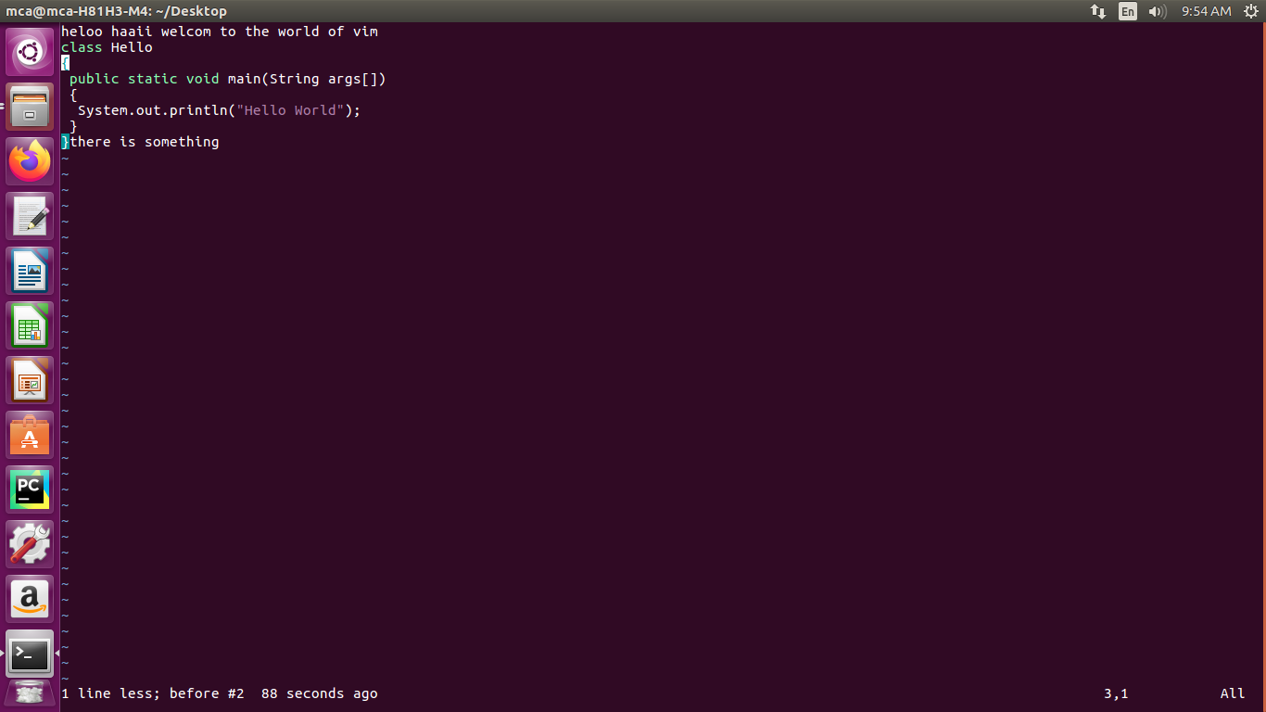

8. To REDO

Enter Esc Ctrl r

9. To set Number

Enter Esc:set number

10.To delete a single line

Enter Esc dd

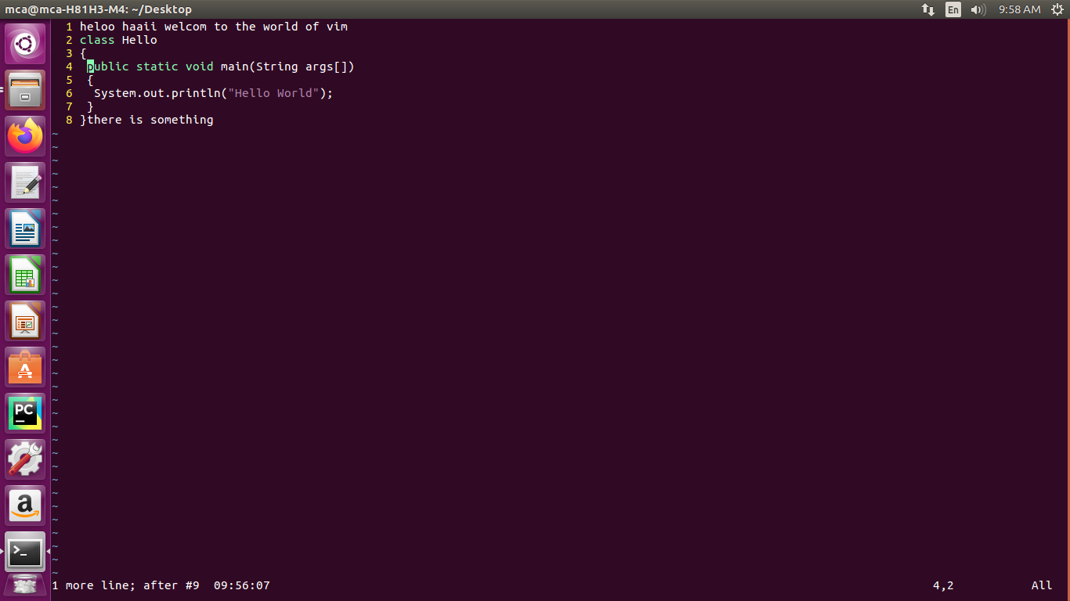
11.To delete one word

Enter Esc dw

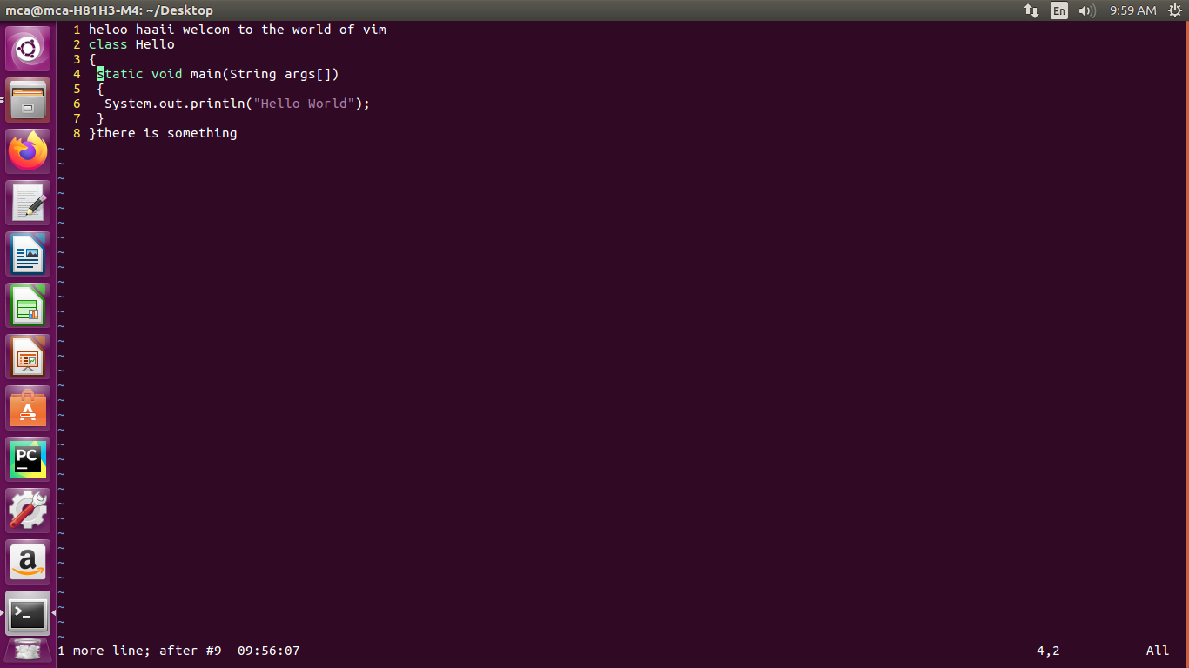

12. Start to move to the end of the next word

Enter Esc e

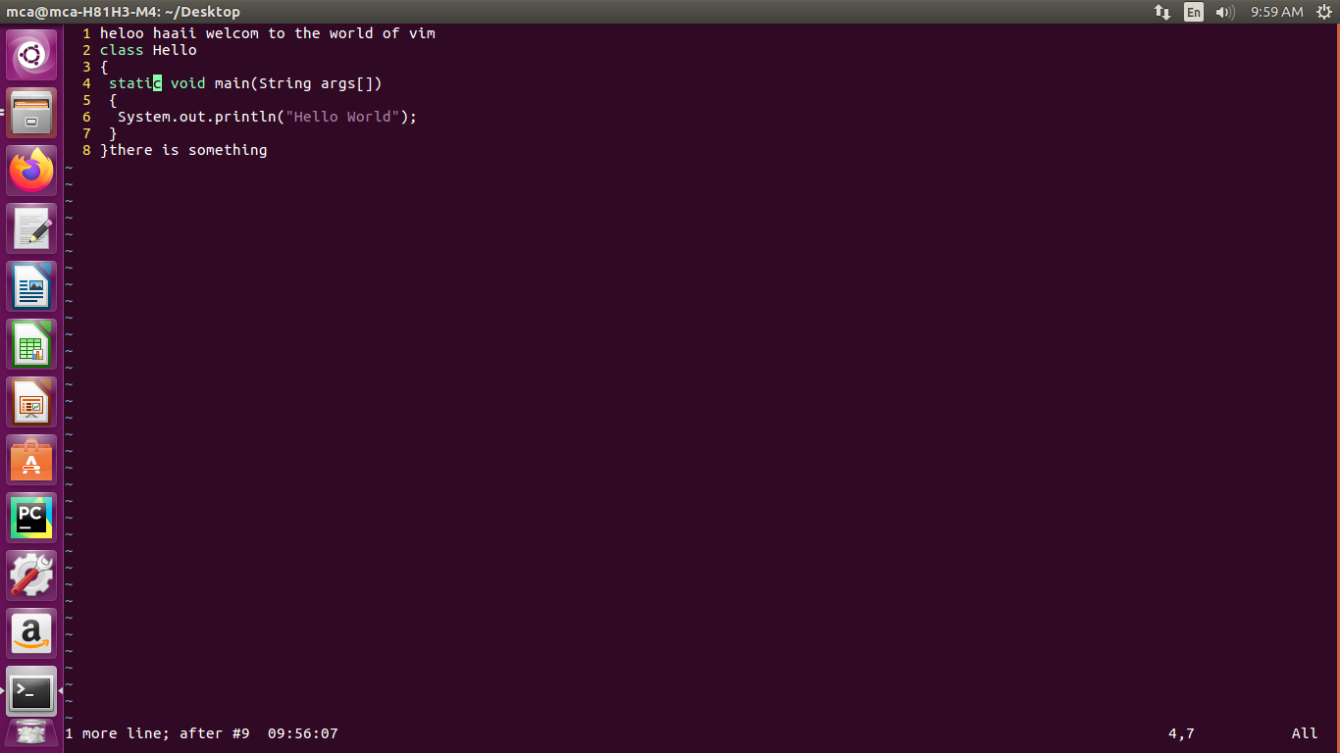
13.To copy the line

Enter Esc yy

14.To paste

Enter p

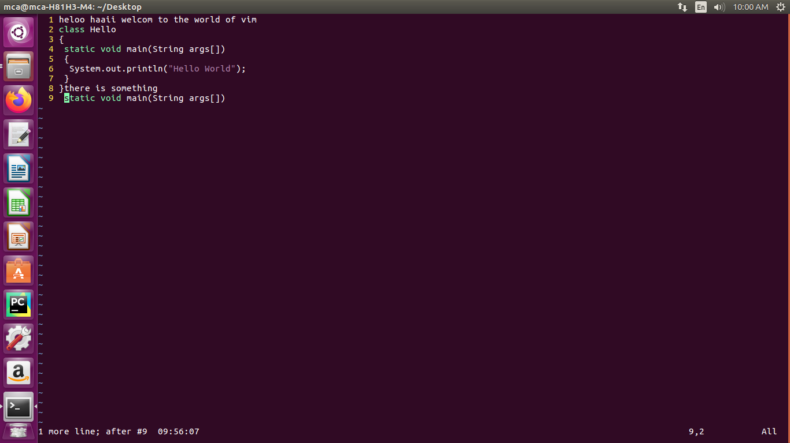
15.To search a specific word

Enter /static(word to be search) shift n

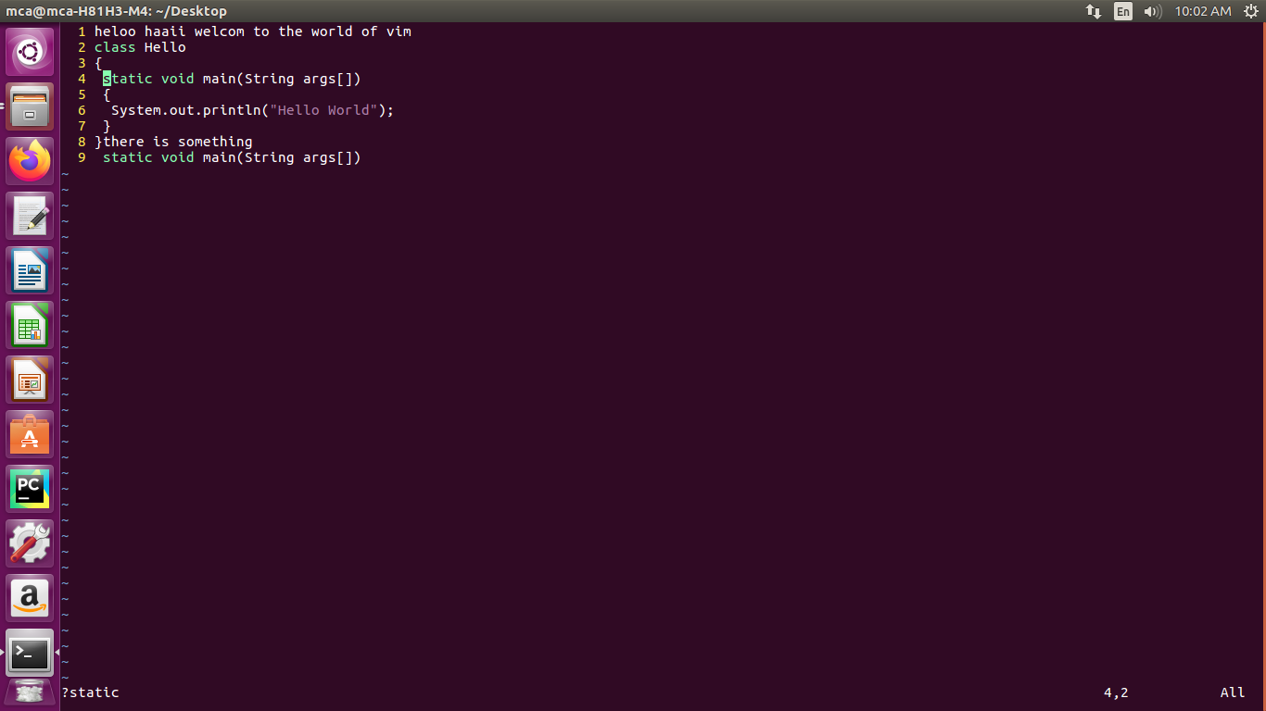

16. To change the specific word by another

Enter Esc:%s/static(orginal word)/maniac(changing word)

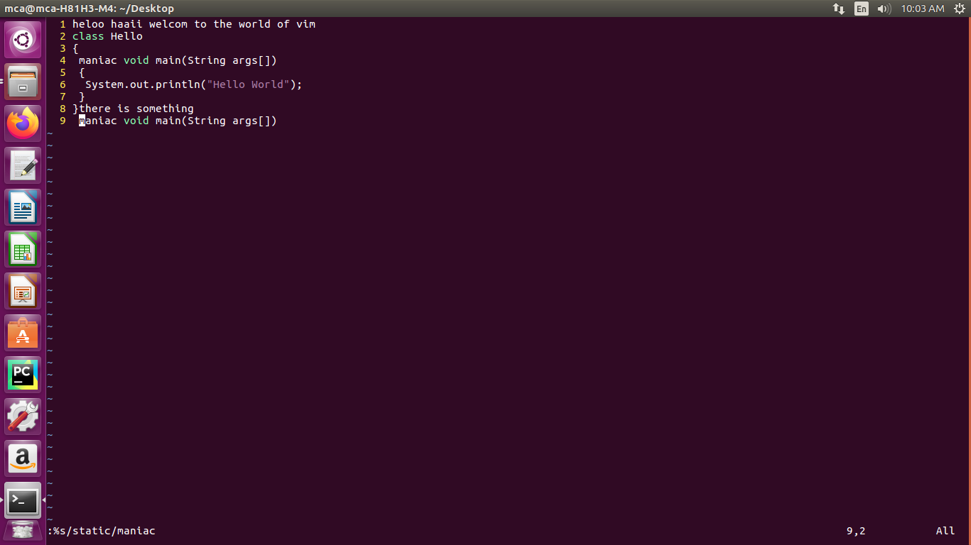
17. To change the specific word line by line

Enter Esc:%s/maniac(orginal word)/static(changing word)/gc

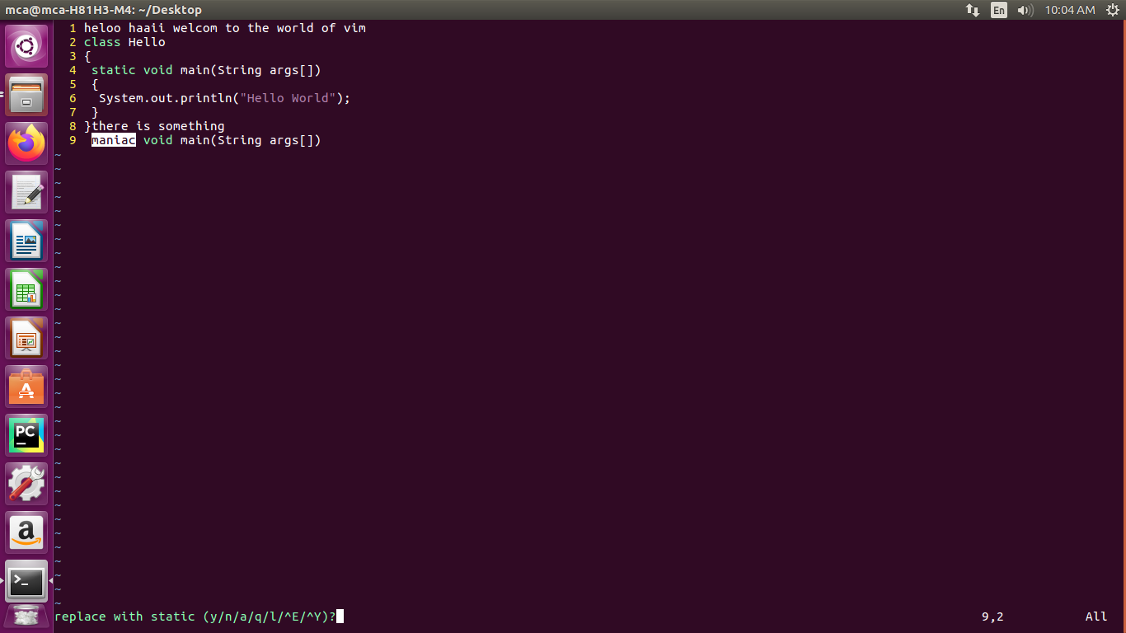

18.To move cursor Left
Enter Esc h

19.To move cursor Right
Enter Esc l

20.To move cursor Down
Enter Esc j

20.To move cursor up
Enter Esc k

